Corporate Club Search EN - INT


BOOK&MANAGE EXPERIENCE DEALS DESTINATIONS MILES&SMILES Sign up SIGN IN

Manage your booking


Budapest - Abuja Round trip
Departure Sunday, May 10 - Return Monday, May 18

RKKE6H
Reservation code
Add ﬂight
Cancel ﬂight
Check-in opens:
36 Days 19 hours
Change ﬂight Add infant
passenger

Flight
Budapest (BUD) Abuja (ABV) 10 May Sunday 2026

Economy Class

Flight status
Survey
On time



Corporate Club Search EN - INT

BOOK&MANAGE EXPERIENCE DEALS DESTINATIONS MILES&SMILES
09:00 19:35 Total travel time
IST
BUD ABV 11h 35m Economy, T-T Itinerary details 
Budapest Abuja
Sign up

Flight details
09:00 BUDAPEST

Airline - Flight number:

Budapest Ferenc Liszt International Airport (BUD) Turkish Airlines - TK1036

2h 15m
Aircraft type:

12:15 ISTANBUL
Airbus A321neo Narrow body

Istanbul Airport (IST)

2h 55m
Transfer & Flight change for Istanbul Airport

6h 25m
15:10 ISTANBUL

Airline - Flight number: Aircraft type:

19:35 ABUJA
Istanbul Airport (IST)

Turkish Airlines - TK623 Airbus A330-203 Wide-body

Nnamdi Azikiwe Airport (ABV)

Flight
Abuja (ABV) Budapest (BUD) 17 May Sunday 2026 Flight status

Corporate Club Search EN - INT
Economy Class On time

IST Next
21:20 08:05day Total travel time
Itinerary details 

BOOK&MANAGE EXPERIENCE DEALS DESTINATIONS MILES&SMILES
Sign up

ABV
BUD
9h 45m Economy, O-O

Abuja Budapest

Flight details
21:20 ABUJA

Airline - Flight number:

Nnamdi Azikiwe Airport (ABV) Turkish Airlines - TK624

6h 5m
Aircraft type:

05:25 ISTANBUL
Monday, May 18
Airbus A330-203 Wide-body

Istanbul Airport (IST)

1h 45m
Transfer & Flight change for Istanbul Airport

1h 55m
07:10 ISTANBUL
Monday, May 18
Airline - Flight number: Aircraft type:

08:05 BUDAPEST
Monday, May 18
Istanbul Airport (IST)

Turkish Airlines - TK1035 Airbus 321 Neo Narrow body

Budapest Ferenc Liszt International Airport (BUD)

Choose a seat and enjoy a comfortable flight.
Additional services
Select from the exclusive additional services and enjoy your flight more.
Purchase extra baggage and don't leave your belongings behind.
Secure yourself and your loved ones during your journey with our travel insurance policy!

View all additional services




Corporate Club Search
EN - INT
BOOK&MANAGE
EXPERIENCE
DEALS
DESTINATIONS
MILES&SMILES
Sign up

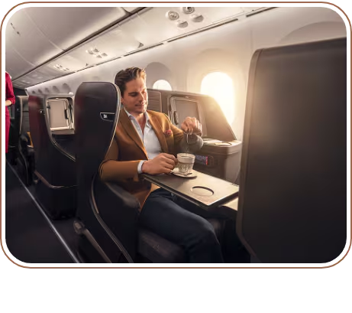
 UPGRADE YOUR FLIGHT ENJOYMENT WITH BUSINESS CLASS

See offers you can benefit from on a trip with Business Class privileges
The opportunity to transform your travels into an unforgettable experience is in your hands; don’t miss out on a journey full of privileges and treats!

 MAXIMUM COMFORT AWARD-WINNING MEALS

 LOUNGE EXPERIENCE  PRIVILEGED CHECK-IN
from 20000 Miles
See offers

Corporate Club Search EN - INT
Book accommodations with us and earn: 2 Miles for every 1 € spent

Abuja

BOOK&MANAGE EXPERIENCE DEALS DESTINATIONS MILES&SMILES
Sign up

654 properties

from US$ 39 per night
Where are you headed?
Abuja

Check-in

05/10/2026
낦 Check-out 낦

05/17/2026


Search

XCover travel insurance

Travel with peace of mind with protection that covers cancellations due to illness and injuries. View details
Trip cancellation: It applies in unforeseen circumstances that force you to cancel your trip.
Medical and dental: Covers emergency treatment costs (international flight bookings only).

Purchase travel insurance
Corporate Club Search
EN - INT
BOOK&MANAGE
EXPERIENCE
DEALS
DESTINATIONS
MILES&SMILES
Sign up
Contact information


Main contact for this trip
Email address
Telephone
Ms. PRECIOUSAKA O
Edit
I want to receive trip notifications via SMS
7037597919
TRAVELSOFTLIMITED@GM

Passenger preferences
Passengers | Seat | Baggage |  | Meals | Special Assistance
Passenger |  |  | Frequent flyer program  /  Membership number
Ms. PRECIOUSAKA ODEY  PO Ticket no 2359410205412 |  |  | Frequent flyer program Join Miles&Smiles  Earn 5365 Miles from this flight.  None

Save
Passenger
Ms. PRECIOUSAKA ODEY  PO Ticket no 2359410205412 | -- | -- | -- | --


Passenger | BUD - ABV  Economy Class | ABV - BUD  Economy Class
Ms. PRECIOUSAKA ODEY  PO Ticket no 2359410205412 | Baggage allowance 2 pieces maximum | Baggage allowance 2 pieces maximum
Carry-on baggage allowance Buy extra baggage
All passengers Business Class
8 kg 1 piece + 1 personal item 8 kg 1 extra piece of baggage

8kg Maximum dimensions for an item of cabin baggage: 55x40x23 cm
 For more detailed information please visit our baggage page.


Passenger | Special meal request
Ms. PRECIOUSAKA ODEY  PO Ticket no 2359410205412 | Which flavors would you like to enjoy on your flight? You can choose any option from our standard menu or select one of our special meals.  Select   I do not want a meal for this ﬂight   View menu
Special meal requests must be placed at least 24 hours before the flight but please note that it may not be possible to meet all requests. For more information, please visit the details on our special meal service page. The meals are prepared and served according to Islamic religious specifications.

Due to operational reasons, the selected meal may not be provided.

Your selection is only valid for Turkish Airlines flights. Catering may not be available for AJet or other airline flights. The catering application of the carrier airline will be valid for those flights.
If you do not request a meal, no meal will be loaded for you on this flight. You can visit our no meal donations page.
Save

Special assistance

To ensure a comfortable travel experience, we support passengers who request special assistance.

Requests must be made at least 48 hours before the flight. It may not be possible to meet all special assistance requests. You can find more information on our passengers requiring special assistance page.

Special assistance request form


Please fill out the form below to request special assistance.

Edit
- Passenger

Ms. PRECIOUSAKA ODEY

-

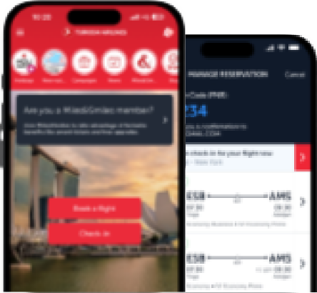
Corporate Club Search
EN - INT
BOOK&MANAGE
EXPERIENCE
DEALS
DESTINATIONS
MILES&SMILES
Sign up
Scan QR and download our mobile app!
Manage your bookings, track flights, check-in, and get updates—all in one place!

Learn more



Sign in to Miles & Smiles
Join Miles&Smiles
Discover the Miles&Smiles world full of privileges!


Learn About Carbon Offset
We all bear responsibility for our Earth – take a step towards a more sustainable journey!
Offset your carbon footprint

Accessibility Privacy & Cookie Policy Legal Notice Passenger Rights Turkish Airlines Copyright © 1996 - 2024
Corporate Club Search
EN - INT
BOOK&MANAGE
EXPERIENCE
DEALS
DESTINATIONS
MILES&SMILES
Sign up

