ANTIFUNGAL RESISTANT DEMATIACEOUS FUNGAL INFECTIONS IN HUMANS: IMPLICATIONS AND INNOVATIVE SOLUTIONS

Anaele, E.N.^{1,2 *}, Amoke, M.C.¹ and Nweke, R.N.¹
¹Department of Microbiology, University of Nigeria, Nsukka, Enugu State.
²South-East Zonal Biotechnology Centre, University of Nigeria, Nsukka, Enugu State.
*Corresponding Author E-mail: eunice.anaele@unn.edu.ng;

Received: 27-12-2025
Accepted: 11-02-2026

https://dx.doi.org/10.4314/sa.v25i1.1
This is an Open Access article distributed under the terms of the Creative Commons Licenses [CC BY-NC-ND 4.0] http://creativecommons.org/licenses/by-nc-nd/4.0.
Journal Homepage: http://www.scientia-african.uniportjournal.info
Publisher: Faculty of Science, University of Port Harcourt.

ABSTRACT
Dematiaceous fungi are diverse group of melanized fungi that cause infections in both immunocompetent and immunocompromised individuals, ranging from superficial to life-threatening systemic infections, including phaeohyphomycosis, chromoblastomycosis, eumycetoma and sometimes onychomycosis. Infections caused by these fungi are increasing due to advances in medical therapy, a rise in predisposing comorbidities such as diabetes, and recognition of virus-associated fungal diseases during the COVID-19 pandemic. The increasing rate of antifungal resistance poses a great challenge to effective treatment as many dematiaceous molds exhibit acquired resistance to available antifungal agents such as azoles and polyenes. Mutations in drug-target site, melanin mediated drug sequestration, and efflux pump overexpression are among the resistance mechanisms manifested by these fungi often leading to chronic infections. The clinical implications of antifungal resistance in these fungi are significant, as limited therapeutic options result in prolonged morbidity, high mortality, and increased healthcare costs due to disease reoccurrence promoting the need for alternative treatment options. Currently, the emerging innovative approaches to dematiaceous mold infections include surgical intervention and combination of therapy, plant-derived antifungal peptides, photodynamic therapy and use of artificial intelligence (AI) in assisting diagnosis and treatment to advance personalized medicine and improve treatment outcome. As resistance to antifungals continues to grow, proactive and innovative approaches are essential to safeguard public health and ensure the effective management of resistant dematiaceous mold infections.
Keywords: Dematiaceous mold, fungal resistance, novel antifungals, photodynamic therapy, chromoblastomycosis, phaeohyphomycosis.

INTRODUCTION
Dematiaceous fungi are a diverse group of melanized fungi that cause infections in both immunocompetent and immunocompromised individuals, ranging from superficial to life-threatening systemic infections, including phaeohyphomycosis, chromoblastomycosis, eumycetoma, and sometimes onychomycosis (Suman and Kumar, 2024). They are opportunistic pathogens capable of causing infections in humans independent of host immune status. They are a ubiquitous environmental heterogenous group of molds found in the soil and plant matter worldwide (Li and Yoon, 2025). More than 150 species belonging to different genera of dematiaceous fungi have been identified to cause infections in humans and animals, exhibiting different pathogenesis, disease manifestation and species predilection (Li and Yoon, 2025; Kundu et al., 2020). The exposure to these pathogens is common and related to socio-economic factors while the disease development is rare. However, the notable increase in disease distribution reports has been influenced by climate change, and current status of fungal disease recognition after COVID-19 pandemic (He et al., 2022).
The introduction of the dematiaceous fungi into sterile body sites through trauma can lead to evasion of the innate immune system, and possible cerebral infection in both immunocompetent and immunocompromised humans with high mortality (He et al., 2022). Most dematiaceous fungi commonly present as subcutaneous infections, typically following deep inoculation of the fungus into the subcutaneous tissue. These infections usually result in lesions on the legs, hands, or feet. In rare but potentially fatal cases, the infection can spread systemically, leading to cerebral abscesses (Dhawan et al., 2023). Neurotropic dematiaceous fungi have special predilection for the brain, infecting the brain parenchyma to cause rare cerebral infection that affect even healthy immunocompetent individuals (Samaddar et al., 2024). The clinical management of cerebral phaeohyphomycosis is challenging due to its poor response to available antifungal drugs.
Following the era of climate change and COVID 19 pandemic, the incidence of dematiaceous fungal infections increased, and the infections were neglected, misdiagnosed and under-reported even in predominant regions, leading to delayed treatment, complications and death (Franco et al., 2024; Rodrigues and Nosanchuk, 2020). Dematiaceous fungi are endowed with virulence factors that protect fungal cells and reduce efficacy of antifungal drugs. Treatment failure has been blamed on acquired and inherent resistance of the fungal cells to available antifungal drugs, raising the need for proper diagnosis before treatment (Tan et al., 2025; Samaddar et al., 2024). The rising incidence and disease severity of dematiaceous fungal infections afflict both immunocompetent and immunocompromised individuals, and if undiagnosed and untreated, cause irreversible damage such as amputation and blindness, including high mortality among patients with invasive fungal disease (Mitra et al., 2024; Samaddar et al., 2024; Bi et al., 2023). Due to the ubiquitous nature of dematiaceous fungi in the soil and decaying vegetation, the rate of human exposure to the fungal pathogen is high while the public awareness of associated infections is poor and unrecognized even by public health officials. A wake-up call was raised to encourage public health officials to support early diagnosis, treatment and regular surveillance of fungal infections (Rodrigues and Nosanchuk, 2020). The World Health Organization (WHO) recently recognized members of the dematiaceous fungi among the fungal priority pathogens as they pose real threat to public health, exhibiting resistance to common antifungal drugs, and causing invasive and fatal infections (WHO, 2022).
However, despite WHO recognition, there is little or no information on prevalence of dematiaceous fungal diseases, and their therapeutic response, owing to non-inclusion of fungal culture and antifungal susceptibility testing as routine tests in many diagnostic laboratories ((Otto et al., 2023). The absence of fungal diagnostics, insufficient medical mycologists, and lack of fungal disease surveillance programmes in endemic countries influence poor treatment outcome, complications, drug resistance development and unclear disease epidemiology. Thus, public awareness and mycological education become pertinent in reducing disease incidence, early diagnosis and proper treatment geared toward reduction of antifungal drug resistance. This review focuses on disease pathogenesis, disease diagnosis, incidence and spectrum, dematiaceous fungal resistance to antifungal drugs, their mechanisms of resistance, implications of the resistance and the diagnostic challenges of detecting drug-resistant species. It also highlights the innovative solutions to drug-resistant dematiaceous fungal infections such as; combination of therapy, surgical excision, phyto-therapeutic approaches and photodynamic therapy as well as the associated challenges.
Pathogenesis of Dematiaceous Fungal Infections
The disease pathogenesis in immunocompetent hosts is not well elucidated. However, the major portal of entry of dematiaceous fungi is trauma, and the melanin production by fungi has been associated with fungal virulence. It has been proposed that melanin mop-up the hypochlorite, and free radicals released by host’s phagocytes during oxidative burst, thus reducing the potentials of phagocytes on elimination of engulfed fungal cells. The melanin present in fungal cell walls binds free radicals and impair the function of phagocytic cells, thus enhancing the fungi’s ability to cause infection, even in individuals with a healthy immune system (Marples et al., 2021). Melanin also protects fungal cells from environmental stresses and promotes stress tolerance. Thermotolerance, an attribute significant in neurotrophic molds, contributes to fungal virulence, leading to fungal dissemination to cerebral regions.
Disease Diagnosis and Identification of Dematiaceous Fungi
Early and fast disease diagnosis is important for the survival of patients especially in cases of invasive dematiaceous fungal disease. The disease diagnosis is based on the patient’s clinical manifestations and mycological evidence. Histopathology, culture and molecular methods are approved methods of disease diagnosis (He et al., 2022; Chowdhary et al., 2014). The different species of dark mold cannot be distinguished using histopathology; thus, culture and histopathology are simultaneously recommended. Molecular methods like DNA sequencing promote fungal species identification but the expensive cost limits its use in the diagnostic laboratory.
In low resource laboratories, the identification of dematiaceous fungi is primarily based on phenotypic characteristics. The macroscopic and microscopic characteristics are important in the identification of fungi (Mythili et al., 2023). Dematiaceous fungi are dark pigmented fungi that contain melanin-like pigments within their hyphae or spores. The fungi constitutively produce melanin in common mycological growth media such as Sabouraud dextrose agar and potato dextrose agar. Dark or brown pigmentation is observed on the reverse culture plate of dematiaceous fungi indicating the production of melanin-like pigment (Figure 1).
Dematiaceous fungi exhibit a brown coloration in tissue, both in unstained sections and when stained with hematoxylin and eosin. However, when using the Masson-Fontana stain, which specifically highlights melanin, the fungal elements appear brownish-black (Dhawan et al., 2023). Phialemonium species are pale in culture showing melanin production in their cell wall by a special stain like Fontana-masson silver (Westblade et al., 2023).
The disease is underdiagnosed due to poor recognition by medical personnel, misdiagnosis or delayed diagnosis particularly among vulnerable populations. The rarity of the disease has also limited the therapeutic evidence to guide disease management. The absence of regular disease surveillance and limited diagnostic methods hinder detection of fungal disease prevalence and susceptibility to antifungal drugs. Lack of routine antifungal susceptibility testing which should guide disease treatment leads to inappropriate therapy and poor treatment outcome. There is need for promotion of public awareness, regular surveillance, and research for improved diagnosis and treatment of dematiaceous fungal infections.
Clinical symptoms of Dematiaceous fungal infections | Macroscopy | Microscopy
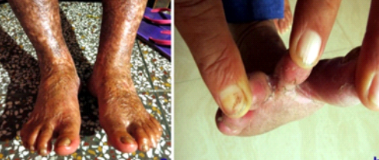  Cutaneous infection (Sharma and Nonzom 2022). | 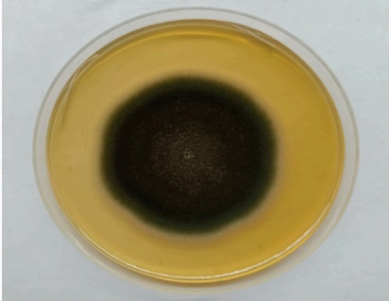  Curvularia lunata on PDA (Kamboj et al., 2022). | 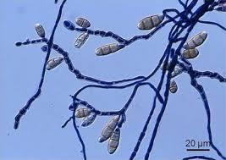  Curvularia sp. (Terada et al., 2014)
Cutaneous infection (Sharma and Nonzom 2022). | 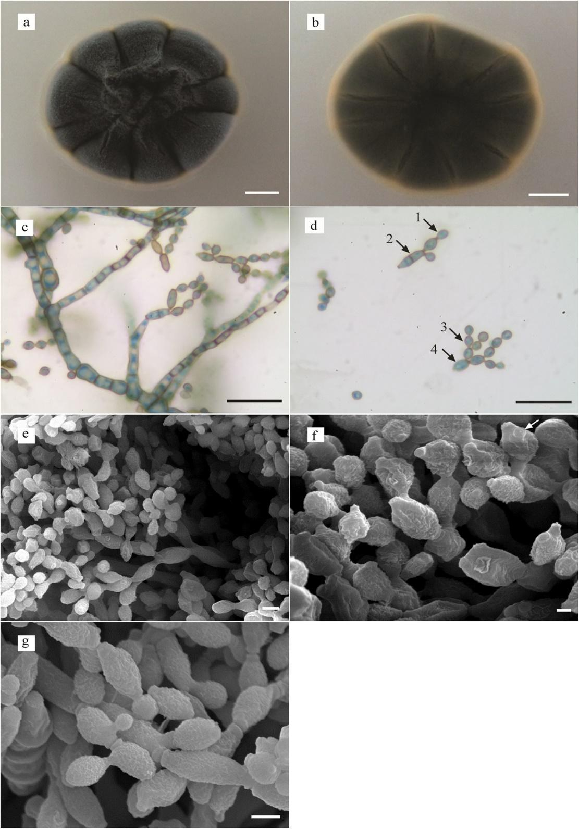  Cladosporium species (Reverse view) Yew et al., 2016. | 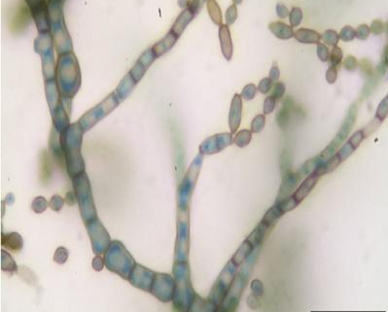  Cladosporium species (Yew et al., 2016)
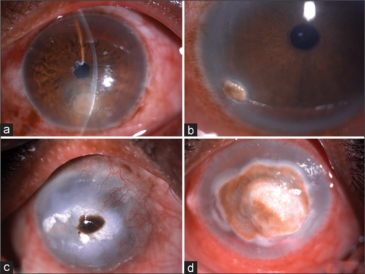  Ocular infection  (Ganesan et al., 2024) | 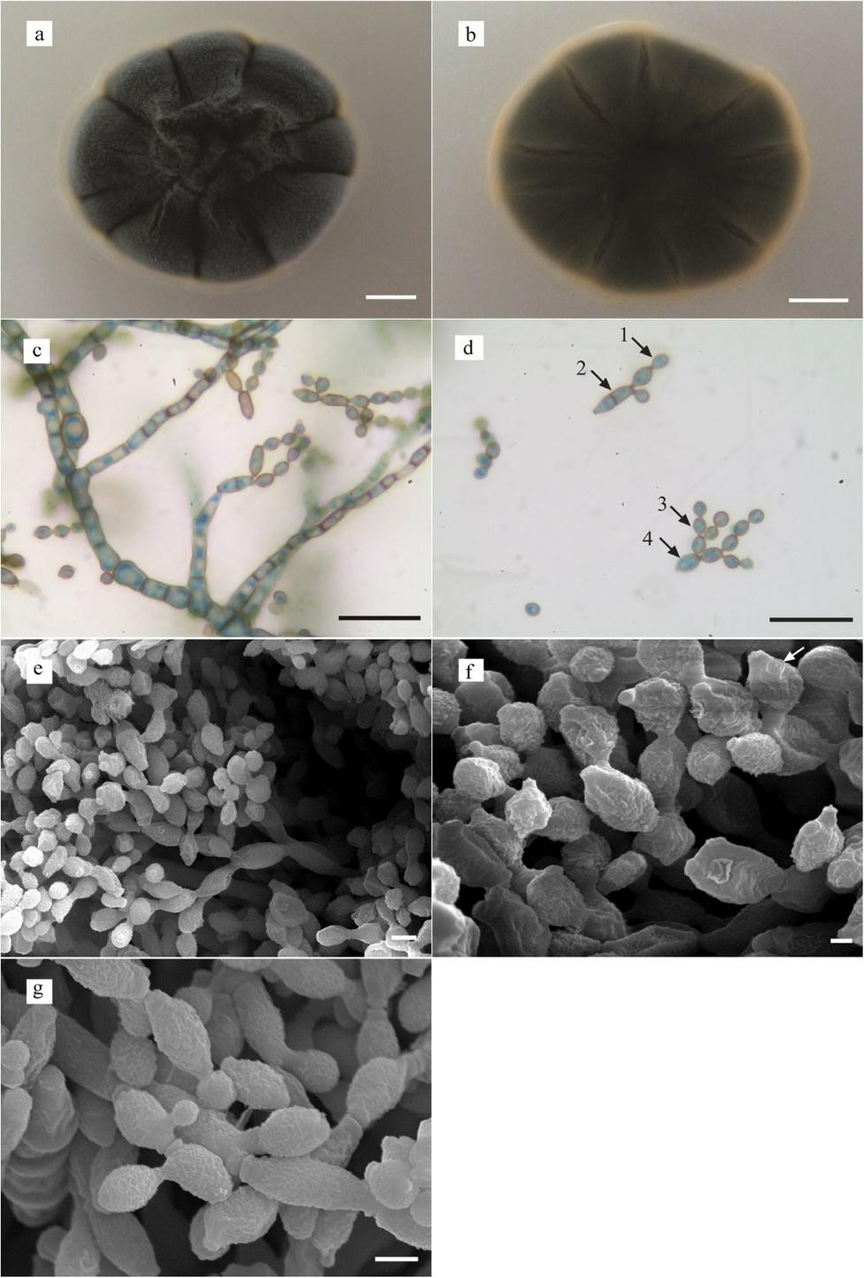  Cladosporium species (Reverse view)  Yew et al., 2016. | 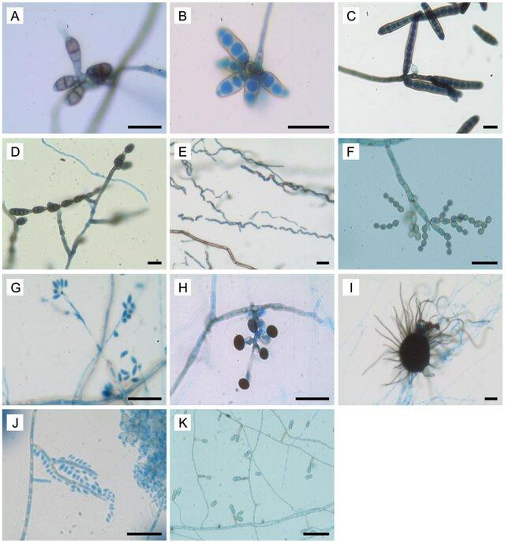  Exophiala species  (Yew et al., 2014)
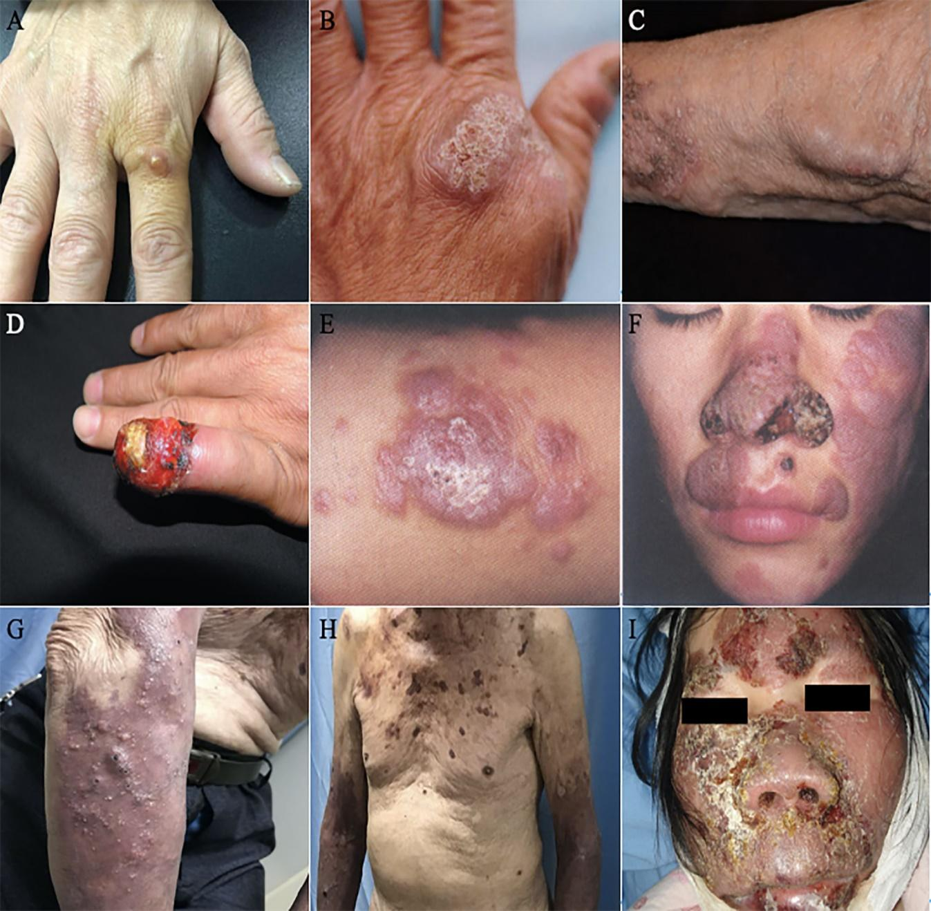  Lesion on patient with phaeohyphomycosis (He et al., 2022) | 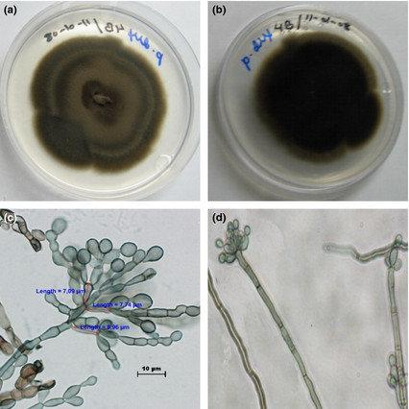  Fonsecaea pedrosoi  (Rojas et al., 2015) | 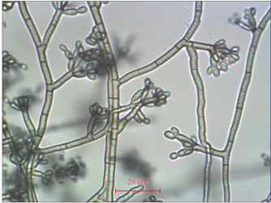  Fonsecaea pedrosoi  (Dong et al., 2018)
Figure 1: Clinical symptoms and characteristics of selected dematiaceous fungi
Disease Incidence and Spectrum of Disease Manifestations
The disease incidence was low in the past but current reports indicate an increasing incidence of dematiaceous fungal infection as a result of improved disease diagnosis, detection techniques, and growing population of vulnerable populations. Dokic et al. (2023) documented that the infection is generally found in endemic tropical and subtropical regions such as Asia, Africa, Latin America and the Caribbean. South America followed by Africa has been reported to have the highest prevalence rates of infection (Santos et al., 2021).
Dematiaceous fungi cause phaeohyphomycosis, which manifests as cutaneous, subcutaneous, and systemic infections, chromoblastomycosis, and eumycetoma which are neglected tropical diseases. Histologically, chromoblastomycosis is marked by the presence of sclerotic or muriform cells, while phaeohyphomycosis is characterized by fungal elements within the tissue (Huang et al., 2022). Eumycetoma or eumycosis is a chronic fungal infection that affects the skin and subcutaneous tissues. The fungus enters the broken skin, manifests as painless nodule, followed by adherence, infiltration, and proliferation in the subcutaneous tissues if untreated, leading to accumulation of pus, swelling, draining sinuses and discharging grains. Disease progression affects the muscles and bones resulting in deformity, disability, and death in extreme cases (Clark et al., 2024).
Pleurostoma species are emerging opportunistic fungal pathogens responsible for phaeohyphomycosis, and have been isolated from subhepatic abscess pus and drainage fluids in a liver transplant recipient with post-transplant biliary and hepaticojejunostomy bypass strictures (Tsang et al., 2024). Dematiaceous fungi are also implicated in mycotic keratitis, and considered as one of the main causes of corneal blindness, implicating species of Curvularia, Exserohilum, Alternaria, Lasiodiplodia, Bipolaris, Nigrospora, and Cladosporium mostly among agricultural workers (Ganesan et al., 2025; Rai et al., 2021). Eye injury from vegetative matter including leaves and sticks was identified as a major predisposing factor of ocular infection. Other dematiaceous fungi such as Arthrinium species, Curvularia species, Pestalotiopsis, and Alternaria have been implicated in cases of onychomycosis (Ye et al., 2025; Borghain et al., 2023).
These fungi are distributed widely in nature and in most cases infected people may be far from medical care or may be treated with natural agents which possibly relieve symptoms but have no effect on the progression of the disease (Cespedes et al., 2024). A condition such as phaeohyphomycosis caused by the melanized fungi has a wide spectrum of clinical manifestations as shown below (Table 1) including cutaneous, subcutaneous and systemic infection which affects both immunocompetent and immunocompromised individuals but has rare occurrence in immunocompetent individuals (Li and Yoon, 2025).
The disease severity is based on different local immune responses related to species specificity. Huang et al. (2022) found that two patients, one harboring P. expanda and the other P. americana distinguished the high tendency of P. expanda forming sclerotic bodies and stronger immunogenicity than P. americana. Due to colony morphology or poor sporulation, the identification of these dematiaceous fungi is quite tricky (Borgohain et al., 2021). In the study of Kumar et al. (2022), dematiaceous fungi like Alternaria and Curvularia were identified in immunocompetent and immunocompromised individuals as causes of fungal sinusitis showing an increasing pathogenic spectrum.
Table 1: Spectrum of Infection and associated species of dematiaceous fungi
Dematiaceous fungal infection | Dematiaceous fungal species | Author
Cerebral Phaeohyphomycosis | Rhinocladiella mackenziei, | Alabdely et al., 2023
 | Fonsecaea monophora  Exophiala dermatitidis | Doymaz et al., 2015  Wang et al., 2019
Paranasal Sinus Phaeohyphomycosis | Bipolaris species, Exophiala species, Curvularia geniculate, Daldina eschscholtzii, Phialemonium species, Medicopsis romeroi, Alternaria species. | Dhawan et al., 2023
 | Pleurostoma richardsiae | Marples et al., 2021
Chromoblastomycosis | Fonsecaea monophora | Santos et al., 2021
 | Exophiala species, Fonsecaea species, Phialophora species | An et al., 2023
Onychomycosis | Pestalotiopsis species, Arthrinium species, Curvulata lunata, Lasiodiplodia theobromae | Borgohain et al., 2023

Dematiaceous Fungal Diseases and Associated Species
Phaeohyphomycosis is a major opportunistic mycosis caused by melanized fungi, characterized by the presence of fungal elements such as hyphae, yeast-like cells or both in affected tissues. The disease manifests as superficial infection or deep tissue infection such as central nervous infection, pulmonary infection, disseminated infection, deep-local infection, and subcutaneous infection. The disease recognition, and increased incidence have been linked to COVID-19 pandemic due to increased use of immunosuppressive drugs which predisposed patients to the fungal disease. The disease has also been related to deficiency of caspase recruitment domain-containing protein 9 (CARD9) gene, which might be natural or acquired (He et al., 2022; Ravankar and Sutton, 2010). Trauma, diabetes, corticosteroids, inherited CARD9 deficiency are risk factors linked to mild phaeohyphomycosis while tumors, malnutrition, chemotherapy, kidney transplantation are risk factors associated with disseminated, pulmonary, CNS, and deep-local infections (He et al., 2022).
Cerebral phaeohyphomycosis is a rare fungal infection that primarily affects the brain of both immunocompetent and immunocompromised individuals, typically linked to poor prognosis (Samaddar et al., 2024; Alabdely et al., 2023). Most of the causative agents of this infection are neurotropic dematiaceous fungi that belong to the order, Chaetothyriales, with Cladophialophora bantiana responsible for a majority of the cases, as well as Vorruconis gallopava, Fonsecaea monophora, Rhinocladiella mackenziei, R. atrovirens, Nodulisporum spp., and Exophiala dermatitidis (Samaddar et al., 2024; Kirchhoff et al., 2019). Phialophora richardsiae is an uncommon cause of human infection; however, when it does occur, it typically presents as a subcutaneous cystic fluid collection characteristic of phaeohyphomycosis (Marples et al., 2021). Although fungi are rare causes of central nervous system infections, the organisms responsible for cerebral phaeohyphomycosis show a distinct preference for brain tissue, though the exact mechanisms behind this neurotropism remain unclear (Samaddar et al., 2024).
Chromoblastomycosis is a granulomatous chronic skin infection due to various dematiaceous fungi invading the subcutaneous tissues of the skin (Liu et al., 2024). Fonsecaea monophora, F. nubica, F. pugnacious and F. pedrosi are the most common pathogenic species causing chromoblastomycosis (Zheng et al., 2023). Based on internal transcribed spacer (ITS) region analysis, Fonsecaea moonphora was segregated from Fonsecaea pedrosoi, one of the major agents of chromoblastomycosis (Bi et al., 2023).
Onychomycosis is an infection of the nail caused mostly by dermatophytes. It has been observed that Curvularia lunata, a dematiaceous fungus, is one of the causative agents isolated from immunocompetent individuals in rare cases of onychomycosis (Hallal and Obeid, 2025). Neoscytalidium dimidiatum is known as a plant pathogen (Dy et al., 2022), however in the study of Hakim et al. (2025) it was considered as an emerging dematiaceous fungal pathogen causing onychomycosis in human.
Predisposing Factors to Dematiaceous Fungal Diseases
The major risk factor of invasive dematiaceous fungal diseases is trauma. Other risk factors include occupational exposure (farming), socio-economic factors, climate (tropical or subtropical areas), contamination of sterile intravenous medical products, immunosuppression, underlying health conditions such as diabetes, malnutrition, and malignancies (Table 2). The contamination of intravenous medical has been associated with the outbreak of systemic fungal infections (Li and Yoon, 2025).
The dematiaceous fungal disease occurrence in males is increasing and outnumber that of females due to outdoor work that exposes males to pathogens in soil and vegetation (Marples et al., 2021). Dematiaceous fungal infections can occur at any age, and a recent report has documented cases of phaeohyphomycosis in pediatric patients (Pinheiro et al., 2019). While individuals in their most active years appear to be more commonly affected, no age group is exempt from the risk of infection (Dhawan et al., 2023).
Dhawan et al. (2023) also showed males to be more prone to the diseases as they get more exposed to outdoor activities than females, increasing disease vulnerability of males. In another study, Huang et al. (2022) reported that CARD9 mutations predispose patients to phaeohyphomycosis caused by Phialophora expanda. However, fungal specificity played a role CARD9 deficient patients where the dematiaceous fungal infections cause significant impairment of the secretion of inflammatory cytokines and the differentiation of T-helper cells in the patient (Huang et al., 2022).
According to Dhawan et al. (2023) trauma was the major source of infection which indicates that there might be inoculation of dematiaceous fungi following trauma. In a case study, Marples et al. (2021) reported occurrence of dematiaceous fungal disease in a retired male patient known to walk either barefooted or in open footwear, and undergoing treatment with ruxolitinib for six months for myelodysplasia, which compromised his immunity and increased his susceptibility to invasive fungal infections. In another study, Borgohain et al. (2023) reported dematiaceous fungi as one of the causative agents of onychomycosis among agricultural workers who walked barefooted.
Cases of cerebral phaeohyphomycosis are generally rare and occur sporadically across different regions. However, infections caused by Rhinocladiella mackenziei are an exception, as they predominantly occur in the Middle East (Alabdely et al., 2023).
Table 2: Risk factors of dematiaceous fungal infections
Clinical disease Manifestation | Risk factors | Dematiaceous fungal species
Cerebral infection | Immunocompetent, immunocompromised conditions | Cladophialophora bantina, Rhinocladiella mackenziei, Exophiala, and Verruconis species.
Pulmonary infection | Immunocompromised conditions | Exophiala, Verruconis, and Chaetomium species.
Disseminated infection | Immunocompromised conditions (malignancy, organ transplant), diabetes, asthma. | Bipolaris, Exophiala, Lomentospora, and Verruconis species.
Allergic fungal sinusitis | Immunocompetent and atopic patients. | Curvularia, Alternaria, and Exserohilum species.
Fungal keratitis | Tropical regions, trauma. | Alternaria, Bipolaris, Curvularia, Exserohilum species.
Superficial and cutaneous infection | Immunocompromised, and trauma. | Exophiala, Bipolaris, Alternaria, and Phialophora species.
Eumycetoma | Poor socio-economic status, laborers, tropical and subtropical areas. | Exophiala, Madurella, and Medicopsis species
Chromoblastomycosis | Poverty, farm work, tropical and sub-tropical climate. | Cladophialophora, Fonsecaea pedroisoi.
Sources: Li and Yoon, 2025; Sharma et al., 2025; Ganesan et al., 2024.
Antifungal Resistance in Dematiaceous Fungi
Antifungal resistance occurs when a drug used to treat fungal infection becomes ineffective. Certain dematiaceous fungal species naturally exhibit resistance to specific antifungal treatments. Conducting antifungal susceptibility testing is crucial for monitoring resistance patterns and evaluating the in vitro activity of both new and existing antifungal drugs. Voriconazole, itraconazole and amphotericin B are considered to be important drugs in the treatment of dematiaceous fungal infections (Mythili et al., 2023). However, reduced antifungal susceptibility of dematiaceous fungi has been reported (Tan et al., 2025; Fukuoka et al., 2024; Shobana et al., 2015). Tsang et al. (2021) reported the MIC values of amphotericin B was ≤1 µg/ml in 64.3% of Pleurostoma strains tested. Chakrabarti et al. (2016) also indicated that fluconazole has negligible activity against dematiaceous fungi and therefore plays no role in essential therapy.
Patients undergoing long-term treatment are prone to resist antifungal drugs, contributing to a high risk of recurrent infection (Sousa et al., 2022). Fibrosis has been noted as the main cause of blockage to successful oral antifungal management (Wu and Hu, 2022). Also, severe and frequent antifungal-resistant infection has been reported in patients taking oral tacrolimus (Mattews et al., 2023).
Mechanisms of Antifungal Resistance in Dematiaceous Fungi
There are different approaches employed by these fungi to resist the activity of antifungal drugs such as increasing the production of melanin in their cell wall (Heidrich et al., 2021), and subsequent conferment of protection against environmental stressors including extremes of temperature. Echinocandins play a limited role in managing cerebral phaeohyphomycosis because they penetrate the cerebrospinal fluid poorly, and most dematiaceous fungal species exhibit high minimum effective concentration (MEC) values against them (Chakrabarti et al., 2016).
Melanin-mediated drug sequestration
Melanin is a high-molecular-weight pigment found in the cell walls of dematiaceous fungi, synthesized primarily through the dihydroxynaphthalene (DHN) pathway. It contributes significantly to the virulence and antifungal resistance of these organisms (Osset-Trenor et al., 2023). Melanin acts as a physical and chemical barrier by binding to antifungal molecules, particularly polyenes such as amphotericin B. This binding reduces the availability of the drug at its site of action (the fungal cell membrane) thereby diminishing its fungicidal effect. Melanin also interferes with reactive oxygen species (ROS) generated by both host immune responses and certain antifungal agents, reducing oxidative damage and enhancing fungal survival (Fisher et al., 2022).
Melanin plays a role in environmental resilience, and fortifies the fungi to withstand extreme temperatures, enzymatic degradation, and desiccation (Arastehfar et al., 2020). The protective role is mirrored during antifungal therapy, where melanin-containing cell walls demonstrate reduced permeability and increased rigidity, further limiting drug penetration. Evidence from experimental models has shown that melanin-deficient mutants of dematiaceous fungi exhibit increased susceptibility to antifungal agents, suggesting the role of this pigment in drug resistance (Gnat et al., 2021).
Cell wall and membrane barrier function
The structural architecture of the fungal cell wall and membrane is a crucial determinant of antifungal resistance. In dematiaceous fungi, the cell wall is composed of multiple layers, primarily chitin, β-1,3-glucans, and mannoproteins, with melanin incorporated into the outer layers. This complex matrix serves as a formidable physical barrier to antifungal penetration (Mueller et al., 2021). The outer layers of the wall are often thicker and more densely pigmented in dematiaceous fungi compared to non-melanized molds, providing additional protection.
The fungal cell membrane, particularly its ergosterol content, is the target of several antifungal classes. Azoles inhibit the synthesis of ergosterol by blocking lanosterol 14α-demethylase, while polyenes bind directly to ergosterol, creating pores in the membrane (Kirchoff et al., 2017). However, dematiaceous fungi can alter membrane composition through the reduced expression of ergosterol or the incorporation of alternative sterols, reducing the efficacy of these drugs. Additionally, the overall fluidity and permeability of the membrane may be modulated under antifungal pressure, further limiting drug action (Sanyaolu et al., 2022).
Cell wall remodeling enzymes may be upregulated in response to antifungal treatment, resulting in dynamic structural changes that enhance resistance. These include increased chitin synthesis as a compensatory mechanism against cell wall-active drugs like echinocandins, which inhibit β-1,3-glucan synthesis. In dematiaceous fungi, the combination of melanin deposition and robust cell wall architecture contributes significantly to intrinsic antifungal resistance (Nnadi and Carter, 2021).
Mutation of antifungal drug-target site
Various antifungal agents including azoles, echinocandins, manogepix, and orotomides act by targeting key enzymes essential to the fungal pathogens, such as Erg11/Cyp51, Fks1, Gwt1, or DHODH (Isa-Isa et al., 2012). As a result, mutations that alter the structure of these target enzymes can reduce the drug’s ability to bind effectively, while still preserving enough enzyme function. The mechanism is a potential source of acquired resistance (Coelho et al., 2022). Azoles act by inhibiting the enzyme lanosterol 14α-demethylase, encoded by the CYP51A gene (or homologous genes in various fungi), which is critical in the biosynthesis of ergosterol. Resistance arises when point mutations in the CYP51A gene lead to structural changes in the enzyme, reducing its binding affinity for azoles while retaining its enzymatic activity (Ahmed et al., 2021). These mutations can emerge during prolonged or subtherapeutic exposure to azoles, especially in chronic infections where drug concentrations fluctuate or biofilm formation is present. In dematiaceous fungi, sequencing of resistant clinical isolates has revealed diverse mutations affecting the substrate-binding region of the enzyme. Some of these alterations are analogous to those seen in Aspergillus fumigatus, suggesting a conserved resistance mechanism across filamentous fungi (Bengyella et al., 2017).
Efflux pump overexpression
Efflux pumps are transmembrane proteins that actively export toxic substances, including antifungal agents, out of the fungal cell. A significant share of clinical antifungal resistance is linked to the activity of ATP-binding cassette (ABC) transporters and major facilitator superfamily (MFS) efflux pumps found in the fungal plasma membrane (Gnat et al., 2021). Overexpression of these pumps decreases intracellular drug concentrations, thereby reducing efficacy, particularly of azole antifungals. ABC transporters, such as those analogous to Candida albicans Cdr1p and Cdr2p, utilize ATP hydrolysis to power the extrusion of drugs (Hossain et al., 2022). MFS transporters, on the other hand, typically function through proton gradient-driven transport. Genes encoding these pumps may be constitutively expressed or induced in response to antifungal exposure. Regulatory networks such as transcription factors (e.g., TAC1 or MRR1 homologs) play a pivotal role in upregulating pump expression under stress conditions (Osset-Trenor et al., 2023).
Fungi dedicate a considerable part of their genomes to encoding transport proteins, with around 10 to 30 transporter genes present per mega base of genomic DNA (Hoenigl et al., 2021). Inhibition of these pumps or suppression of their gene expression has been shown in vitro to restore azole susceptibility.
Biofilm formation
Biofilms are organized communities of microbes that attach to surfaces and are embedded within a self-generated extracellular matrix (e.g., tissue) and abiotic (e.g., catheters, prosthetic devices) (Gao et al., 2018). Dematiaceous fungi are capable of forming dense, pigmented biofilms that exhibit profound resistance to antifungal agents. The matrix, composed of polysaccharides, proteins, and extracellular DNA, impedes drug penetration and creates microenvironments where cells are shielded from both antifungal compounds and host immune factors (Song et al., 2020).
Dematiaceous fungal cells within biofilms display altered phenotypes compared to planktonic (free-living) cells. These include changes in gene expression, reduced growth rates, and the emergence of metabolically inactive persister cells. Persister cells are highly tolerant to antifungal agents, not due to genetic resistance but due to their dormant state, which renders them less susceptible to drugs targeting actively dividing cells (Kirchoff et al., 2017).
Biofilm-associated resistance is particularly problematic in clinical settings, as infections involving medical devices or chronic wounds often involve biofilm-forming organisms (Sousa et al., 2022). Standard antifungal concentrations are often ineffective against biofilms, necessitating higher doses or combination therapies that may not be well tolerated (Kim et al., 2020).
Distribution of antifungal drug resistant dematiaceous fungi
Antifungal susceptibility testing is critical in the management of dematiaceous fungal diseases and optimal drug selection. However, the antifungal susceptibility testing has not been adopted as routine laboratory test in many diagnostic laboratories (Otto et al., 2023). Few researchers have documented the evidence of antifungal resistance in dematiaceous fungi from different parts of the world and the need for susceptibility testing especially in cases of suspected invasive fungal infection. A study in China reported 93% resistance to fluconazole while high susceptibility was recorded for terbinafine (89%), voriconazole (86%), and itraconazole (77%), where terbinafine showed the least MIC (He et al., 2022). The new triazoles, isaconazole and ravuconazole have been documented as drugs with better in vitro antifungal activity than itraconazole, posaconazole and voriconazole against Bipolaris spicifera, and Veronaea botryose (Zheng et al., 2020). The distribution of resistant dematiaceous fungi is shown on Table 3.
Table 3: Reports on distribution of resistant dematiaceous fungi
Antifungal agents | Clinical manifestation | Resistant species | Region | Author
Amphothericin B | Ocular infection | Curvularia species | India | Mitra et al., 2024.
Amphothericin B | Ocular infection | Cladophialophora boppi | Malaysia | Tan et al., 2025.
Amphothericin B | Peritonitis | Curvularia species | India | Varughese et al., 2011.
Amphotericin B | Superficial mycosis | Alternaria alternata | India | Sharma and Nonzom, 2022.
Voriconazole + Everolimus | Chromoblastomycosis | Fonsecaea pedrosoi | China | An et al., 2023.
Fluconazole and micafungin | Cerebral phaeohyphomycosis | Fonsecaea monophora | China | Bi et al., 2023.
Flucytosine | Primary cerebral phaeohyphomycosis | F. monophora, Cladosporium cladosporioides | India | Samaddar et al., 2024.

Diagnostic Challenges in Detecting Antifungal Resistance
Antifungal therapy relies on four classes of drugs, namely, azoles, polyene, echinocandins and the nucleotide analogue 5-flucytosine. The sustainability of antifungal susceptibility testing depends on accurate identification of fungi, acquisition and maintenance of quality control strains, laboratory and clinical training, development of clear protocol for susceptibility testing, access to media and reagents, regular participation in external quality assurance programmes. The requirements mentioned above can only be achieved through proper funding.
Diagnostic challenges in fungal identification
A proper identification of the causative fungal pathogen is important to provide best antifungal therapy. Hakim et al. (2025) and Pontarelli et al. (2005) noted the sensitivity of Neoscytalidium dimidiatum to cycloheximide leading to fungal growth failure in SDA supplemented with cycloheximide. Species-level identification based on macroscopic and microscopic examination of culture is obstructed due to intraspecies morphological pleomorphism (Ahmadi et al., 2015). Sequencing analysis of ITS rDNA region is essential to differentiate N. dimidiatum from other species within Neoscytalidium genus (Shokoohi et al., 2020), the method is financially demanding thereby imposing a big diagnostic challenge in detecting resistance.
Delayed diagnosis or misdiagnosis due to the rarity of dematiaceous fungal infections is a significant challenge in clinical care of vulnerable populations, and poses a great challenge in detecting resistant dematiaceous fungi in clinical samples (Li and Yoon, 2025). He et al. (2022) reported 74% misdiagnosis in phaeohyphomycosis which highlights the ongoing challenges in disease diagnosis and treatment.
Diagnostic challenges in antifungal susceptibility test and interpretation
Unlike bacteria, antifungal susceptibility of dematiaceous fungi require long turnover time due to slow fungal growth. Various susceptibility testing methods have been applied in fungal research, namely: broth dilution methods, agar diffusion method, sensititre yeastOne assay, Vitek 2 yeast susceptibility panels, flow cytometry, time-kill studies, providing quantitative or qualitative results. Out of these methods, only broth microdilution and disk diffusion methods have been used for susceptibility testing of dematiaceous fungi. The microbroth dilution method, the gold standard, is the Clinical Laboratory Standard Institute (CLSI) and European Committee on Antimicrobial Susceptibility Testing (EUCAST) approved method for antifungal susceptibility of dematiaceous fungi (Samaddar et al., 2024; CLSI, 2008). These methods are associated with different challenges, including fungal inoculum standardization, availability of approved medium (RPMI 1640 for broth dilution methods), and expensive laboratory equipment and consumables. Broth microdilution method is labour intensive and the cost of commercially prepared plates is unaffordable for low-cost laboratories. Technical training of personnel is highly required for correct execution of antifungal susceptibility test.
Disk diffusion method is another standard method for antifungal susceptibility testing approved by CLSI and EUCAST. Although standardized and inexpensive, the results gotten from the disk diffusion method for dematiaceous fungi do not correlate with the MIC values from broth microdilution method. Correlation of MIC results with inhibition zone diameter has been established for some species of yeasts but not mold (Samaddar et al., 2024). Standard drug disks are commercially available for only few antifungal drugs. Agar screening method has been developed for Aspergillus species which is easy to perform and interpret but the method is a screening method which requires broth dilution method for a back-up (Berkow et al., 2020).
There is no interpretative breakpoint to guide optimal antifungal therapy, and no approved method for evaluation of in vitro efficacy of antifungal drug combinations to improve treatment outcome especially for invasive infections caused by dematiaceous fungi. Each antifungal exhibits specific impact on mold growth which requires unique endpoint for interpretation. It is also difficult to correlate in vitro susceptibility test results with in vivo treatment success.
In addition to detection of phenotypic resistance through MIC-based antifungal susceptibility methods, molecular testing methods can be used to detect mutation in specific gene responsible for the susceptibility of antifungal drug. The method can only detect known molecular resistance mechanisms and its application in treatment is dependent on increased understanding of fungal resistance mechanisms (Otto et al., 2023).
Implications of Antifungal Resistance in Dematiaceous Fungi
Antifungal resistance in dematiaceous fungi is associated with treatment failure, reduced treatment options, high mortality, emerging superbugs, prolonged hospitalization, and increased cost of healthcare. It increases the challenges of diagnosis for effective treatment and identification of resistance mechanism. It is a great challenge in developing countries where there is limited availability of some antifungal formulations.
Refractory infections due to treatment failure
Antifungal resistance leads to treatment failure and refractory infection due to reduced drug efficacy. Development of cardiac Q-T prolongation was caused by itraconazole after several weeks of administering it on a woman with chromoblastomycosis which was discontinued, followed by the administration of terbinafine 250 mg daily for three months but had no effect (Martinelli et al., 2024). The clinical handling of cerebral phaeohypomycosis is demanding because of the limited effectiveness of current antifungal treatment (Samaddar et al., 2024). Ganesan et al. (2024) reported the treatment outcomes for fungal keratitis involving various species of dematiaceous fungi using antifungal medication (such as natamycin and voriconazole) where complete healing was recorded for Bipolaris and Nigrospora species, followed by Curvularia (90%), Exserohilum (80%), Alternaria (80%), and Lasodiplodia (75%) while Cladosporium species required therapeutic penetrating keratoplasty (TPK).
Increased morbidity and mortality rates in immunocompromised patients
Alabdely et al. (2023) identified R. mackenziei as the most prevalent fungus that leads to cerebral phaeohyphomycosis cases and is associated with high mortality at a tertiary hospital in Riyadh, Saudi Arabia. He et al. (2022) also reported the mortality rates of pulmonary (25%), disseminated (36%), and cerebral (55%) phaeohyphomycosis, where nearly 19% of patients involved had poor quality of life caused by complications such as disability, disfigurement and blindness.
The prognosis for cerebral phaeohyphomycosis remains poor regardless of patient’s immune statue, with almost 70% mortality rate even when patients were treated with combination of surgical intervention and major antifungal classes including polyenes, echinocandins, azoles and the nucleoside analog 5-flycytosine (Samaddar et al., 2024). Oral antifungal fluconazole, may prolong the QT interval and pose cardiovascular risks (Maskan Bermudez et al., 2023). Lang et al. (2018) reported that while the systemic infections of Exophiala dermatitidis are exceedingly rare, they are associated with both significant mortality and morbidity. It was also reported that infections caused by this dematiaceous fungus can range from mild skin conditions to severe systemic diseases, with a fatality rate of about 40% (Usuda et al., 2021).
Innovative Approaches to Treatment of Resistant Dematiaceous Fungal Infections
Dematiaceous fungi are characterized by their dark pigmentation, and are known for causing infections such as chromoblastomycosis, phaeohyphomycosis, eumycetoma, and sometimes onychomycosis. Antifungal drugs are the primary therapeutic choices for these infections; however, the increasing rate of resistance in dematiaceous fungal infections has led to the exploration of novel approaches. Exploration of innovative therapeutic strategies are essential to combat the rise in antifungal resistance among these pathogens as discussed below.
Combination therapies to overcome resistance
Monotherapy results in therapeutic failure and possible use of combination therapy. Combination therapies provide an enhanced plan for prevention of drug resistance, and promotion of efficacy, allowing for a lower dosage but minimizing dose-related toxicity which may occur. The combination of extended-spectrum triazole and 5-flucytosine has demonstrated an in vitro efficacy against various black molds, although surgical removal remained crucial for a successful outcome (Alabdely et al., 2023). There is no established standard treatment for phaeohyphomycosis but broad-spectrum triazoles such as isaconazole, itraconazole, voriconazole and posaconazole currently serve as the cornerstone of therapy (Arcobello and Revankar 2020), but the combination of isavuconazole and 5-flucytosine was reported to be antagonistic and should be avoided (Samaddar et al., 2024). The report of the synergism of Pyrvinium pamoate with itraconazole, voriconazole and posaconazole were observed against 88.9%, 50% and 72.2% strains of Exophiala dermatitidis biofilms respectively (Sun et al., 2020).
In the treatment of cerebral phaeohyphomycosis, echinocandin is not recommended as a monotherapy due to poor penetration of the drug in the cerebrospinal fluid and the high minimum effective concentration exhibited by the dematiaceous fungi (Samaddar et al., 2024). Thus, to avoid refractory cerebral infection, echinocandin must be combined with azole and flucytosine. The double combination of echinocandin and a triazole (voriconazole + caspofungin; itraconazole + anidulafungin) is a promising therapeutic option for cerebral infection. When surgery is not an option, using a combination therapy of a triazole, 5-flucytosine, and an echinocandin is linked to survival outcomes, and can serve as the primary treatment approach (Chowdhary et al., 2014). Samaddar et al. (2024) also reported a better in vitro activity of triple combination of echinocandin, 5-flucytosine, and either amphotericin B or a triazole against neurotropic dematiaceous fungi than the double combination.
Everolimus, an immunosuppressant to prevent rejection of organ transplants has been successfully combined with antifungal drugs against Exophiala species, Phialophora and Fonsecaea isolates which exhibited a synergistic efficacy with amphotericin B, posaconazole, itraconazole but showed none with voriconazole (An et al., 2023). In another study, synergistic effect was observed when amphotericin B was combined with caspofungin and flucytosine as a triple therapy against flucytosine-resistant Cladosporium cladosporioides (Samaddar et al., 2024). Moreover, in the use of combination therapy involving terbinafine, careful measures should be employed to avoid hepatic injury. Liver function tests during treatment can serve as an important precautionary measure (Hallal and Obeid, 2025).
Surgical excision approaches
Dhawan et al. (2023) reported that out of 14 patients (70%) treated surgically, 13 of them recovered while one was lost to follow up due to various reasons. The advantage of treatment with surgical excision in subcutaneous phaeohyphomycosis without antifungal has been reported (Chintagunta et al., 2017). Systemic antifungal therapy is typically first-line treatment for chromoblastomycosis; however, surgical excision may be considered for localized lesions refractory to antifungal therapy where wide local surgical excision has been reported to be successful in the proper clinical context (Rolon et al., 2023). Although Exophiala dermatitidis infections are linked to high rates of illness and death, a favorable outcome was attained in immunocompromised patients by employing intensive surgical measures alongside prolonged use of broad-spectrum antifungal therapy (Lang et al., 2018).
Photodynamic therapy
The principles of photodynamic therapy are based on the use of a non-toxic light-sensitive dye called photosensitizer combined with harmless visible light (low energy) of the corresponding wavelength to match the absorption spectrum of the photosensitizer. This principle has been advantageously used in combination with oral antifungals in patients with chromoblastomycosis in current years (Yang et al., 2022; Lan et al., 2021).
Liu et al. (2019) reported the use of aminolevulinic acid photodynamic therapy (ALA-PDT) as adjuvant therapy combined with oral itraconazole and terbinafine to treat immunocompromised elderly woman with phaeohyphomycosis caused by Exophiala spinifera by using 20% 5-ALA red light (633nm) at an intensity of 120 Mw/cm² given over three sessions. Due to diverse clinical manifestations of chromoblastomycosis and its etiological agents, the optimal therapy is yet uncertain, however photodynamic therapy has emerged as a potential physical approach for early treatment of infection (Queiroz-Telles, 2015).
Wu et al. (2025) indicated that 5-aminolevulinic acid photodynamic therapy was used as an adjunctive therapy for chromoblastomycosis, and has resulted in better clinical improvement and recovery using a constructed mouse footpad infection model using F. monophora by enhancing the immune response of macrophages to fungal pathogens through the MACRO receptor. It was also reported that phaeohyphomycosis caused by Cladosporium halotolerans was successfully treated with ALA-PDT since the condition was unsuitable for surgery due to periorbital location of the lesion and a poor response to oral itraconazole (400mg/d) for 9 months (Zhou et al., 2023).
Curvularia lunata, a fungal pathogen of phaeohyphomycosis in human caused a lesion that was successfully treated following a combination of surgical intervention and three sessions of photodynamic therapy (PDT) using 5-aminolevulinic acid at nine-day intervals; which eradicated the pathogens by enhancing reactive oxygen species (ROS) production within them (Wang et al., 2023). Theoretically, photodynamic therapy can prevent recurrent onychomycosis by their anti-biofilm action which involves the breakdown of the protective biofilm matrix and exposure of the fungal cells to therapeutic agents (Wu and Hu, 2022). However, photodynamic therapy has no significant documented long-term adverse effects or accumulated toxicity apart from the transient pain, swelling and small exudation that may occur during the treatment, which are well tolerated (Yang et al., 2022). There is also a rare occurrence of contact allergy to photosensitizer prodrugs.
Phyto-therapeutic approaches
Plant-based compounds also exhibit antifungal activities against dematiaceous fungi. Bektas et al. (2023) revealed that ethanol extracts of plant species of Hypericum perforatum, Hypericum scabrum and Hypericum origanifolium showed antifungal activity on A. alternata. In addition, the efficacy of endophytic fungi isolated from Azadirachta indica roots against Alternaria species has been documented, where metabolites from Trichoderma showed highest zone of inhibition (Ododa et al., 2023). Endophytic fungi coexist harmoniously with the host plants and most times fight against other phytopathogenic fungi (Alvin et al., 2014). In another report, A. alternata growth was not totally inhibited by essential oil of Baccharis dracunculifolia plant, however, the significant reductions in mycelial growth observed at high dose (˃1000µg/ml) of essential oil of Baccharis dracunculifolia is an indicator of its antifungal potential and possible application in the control of the dematiaceous fungus (Debona et al., 2021).
The potent inhibitory properties of essential oil and (-)-α-thujone in Thuja occidentalis was reported against Curvularia lunata and Bipolaris maydis isolated from maize (Bai et al., 2020). Almola et al. (2022) also showed the efficacy of acetone extract of Lecanora muralis in the inhibition of A. alternata, Cladosporium species and Curvularia species at different degrees. The extract of Tonka (Dipteryx odorata) showed a better bio-fungicide against Curvularia eragrostidis according to the EC₅₀ (Hernandez-Navarro et al., 2023). AI-snafi (2015) showed the ethanolic extract of Capparis spinosa to have an antifungal activity in Alternaria alternata. The natural antifungal compounds (curcumin, berberine, eugenol and α-pinene) from plants have exhibited an in vitro antifungal activity against Curvularia lunata by targeting the virulence factors, melanin biosynthesis and spore formation (Kamboj et al., 2022).
The potential for the antifungal action of Fagonia arabica crude extracts to combat Alternaria alternata was revealed in the study of Gebreil et al. (2022) as they were considered safe for human health. The essential oils of Amazonian aniba species also exhibit inhibitory effect on the conidial germination of Alternaria alternata (Souza et al., 2020).
Use of artificial intelligence (AI) in assisting diagnosis and treatment
Due to the shortage of trained mycologists, fungal infections are frequently identified and managed by non-experts which often compromises diagnostic precision and may lead to inappropriate or delayed care (Liu et al., 2020). This challenge has underscored the pressing need for integrating artificial intelligence algorithms to support physicians in prompt diagnosis and treatment. As a branch of AI, machine learning enables systems to automatically perform tasks by detecting patterns within complex datasets (Han et al., 2024). The advancement allows for the analysis of diverse parameters to create tailored treatment and care strategies for effective management of fungal infections. (Hutchinson et al., 2023). According to Koo et al. (2021) researchers trained the YOLO v4 convolutional neural network for object detection using magnified microscopic images to facilitate the automated recognition and identification of fungal structures.
CONCLUSION
Antifungal resistance in dematiaceous fungi poses a great challenge to general health in an era of rising incidence of fungal infections, and limited antifungal regimen. These melanin-like pigmented fungi responsible for a range of infections such as chromoblastomycosis, phaeohyphomycosis and onychomycosis, exhibit intrinsic and acquired resistance mechanisms that lower the efficacy of conventional antifungal therapies. Resistance mechanisms such as melanin mediated drug sequestration, an increase in drug efflux, and structural alteration of the antifungal target site have led to increased morbidity and mortality. However, delays in diagnosis and misidentification have led to inappropriate and ineffective treatment. The limited study on dematiaceous fungi compared to other pathogenic fungi highlights the need for further exploration of their resistance patterns. As antifungal resistance rises globally, it is necessary to adopt comprehensive surveillance programs to emerging resistant strains, and guide clinical decision-making. Innovative solutions are critical to overcoming antifungal resistance in these fungi. Combination antifungal therapy, surgical excision, photodynamic therapy, and phyto-therapeutic approaches show promising potentials in reducing resistance development. Drug repurposing, and exploration of novel antifungal agents including those targeting fungal biofilms and melanin synthesis pathways provide enhanced therapeutic approaches. In addition, application of machine learning and artificial intelligence will advance personalized medicine and improve treatment outcome for dematiaceous mold diseases. As resistance to antifungals continues to grow, proactive and innovative approaches are essential to safeguard public health and ensure the effective management of fungal infections.
Declarations
Ethical approval and consent: Not applicable.
Consent for publication: Not applicable
Funding: None
Availability of data: Not applicable
Competing interests: None
Author contributions
Anaele, EN: Conceptualization, visualization, writing original draft, review, editing and supervision.
Amoke, MC: Writing and investigation
Nweke, RN: Analysis, review and editing of manuscript.
REFERENCES
Ahmadi, B., Mirhendi, H., Shidfar, M. R., Nouripour-Sisakht, S., Jalalizand, N., Geramishoar, M. and Shokoohi, G. R. (2015). A comparative study on morphological versus molecular identification of dermatophyte isolates. Journal of Medical Mycology, 25(1):29-35.
Ahmed, M. Z., Rao, T., Saeed, A., Mutahir, Z., Hameed, S., Inayat, S., Shahzad, H., Ullah, N., Abaid-Ullah, M., Ibrahim, M., Munir, S., Javed, A., Khan, J., Khalid, M., and Ahmed, S. (2021). Antifungal drugs: mechanism of action and resistance. In Biochemistry of Drug Resistance (pp. 143-165). Cham: Springer International Publishing. Doi:10.1007/978-3-030-76320-6_5
Alabdely, M. H., Alolayan, A. S., Almaghrabi, R. S. and Al-Abdely, H. M. (2023). Cerebral phaeohyphomycosis at a tertiary healthcare center in Saudi Arabia. Neurosciences Journal, 28(2):136-142.
Almola, Z., Ramadan, N. and Al-Nima, B. (2022). Effect of extracts of some Iraqi lichens against the growth of some fungi isolated from infected fruits and vegetables. College Of Basic Education Research Journal, 18(3):818-0.
Al-Snafi, A. E. (2015). The chemical constituents and pharmacological effects of Capparis spinosa - An overview. Indian Journal of Pharmaceutical Science and Research, 5(2):93-100.
Alvin, A., Miller, K., and Neilan, B. (2014). Exploring the potential of endophytes from medicinal plants as sources of antimycobacterial compounds. Microbiological Research, 169(7-8):483-495.
An, L., Jia, G., Tan, J., Yang, L., Wang, Y. and Li, L. (2023). Analysis of the synergistic antifungal activity of everolimus and antifungal drugs against dematiaceous fungi. Frontiers Cellular Infection Microbiology, 13:1131416. DOI: 10.3389/fcimb.2023.1131416.
Arastehfar, A., Lass-Flörl, C., Garcia-Rubio, R., Daneshnia, F., Ilkit, M., Boekhout, T., Gabaldon, T. and Perlin, D.S. (2020). The quiet and underappreciated rise of drug-resistant invasive fungal pathogens. Journal of Fungi, 6:138-152.
Arcobello, J. T. and Revankar, S. G. (2020). Phaeohyphomycosis. In Seminars in Respiratory and Critical Care Medicine, 41(1):131-140.
Bai, L., Wang, W., Hua, J., Guo, Z., and Luo, S. (2020). Defensive functions of volatile organic compounds and essential oils from northern white-cedar in China. BMC Plant Biology, 20:1-9.
Bektas, Ġ., Seyrekoglu, F., Kusek, M. and Ceyhan, B. C. (2023). Determination of antifungal activity of leaf extracts from Hypericum ssp. against plant pathogenic fungi Fusarium oxysporum and Alternaria alternata. Journal of the Institute of Science and Technology, 13(4):2364-2372.
Bengyella, L., Yekwa, L. E., Waikhom, S. D., Nawaz, K., Iftikhar, S., Motloi, T. S., Tambo, E. and Roy, P. (2017). Upsurge in Curvularia infections and global emerging antifungal drug resistance. Asian Journal of Scientific Research, 10(4):299-307.
Berkow, E. L., Lockhart, S. R., and Ostrosky-Zeichner, L. (2020). Antifungal susceptibility testing: current approaches. Clinical Microbiology Reviews, 33(3): 10-1128.
Bi, W., Xu, L., Zong, L., Zhu, Z. and Xia, X. (2023). Antifungal susceptibility and biological characteristics of Fonsecaea monophora causing cerebral phaeohyphomycosis in Jinhua, China. Infection and Drug Resistance, 16:7187-7195. Doi: 10.2147/IDR.S425961
Borgohain, P., Barua, P., Mahanta, J., Saikia, L. R., Shaw, D. and Rudramurthy, S. M. (2021). Lasiodiplodia theobromae onychomycosis among agricultural workers: A case series. Journal of Medical Mycology, 31(3):101167. Doi: 10.1016/j.mycmed.2021.101167
Borgohain, P., Barua, P., Shaw, D., Saikia, L. R., Mahanta, J. and Rudramurthy, S. M. (2023). Onychomycosis caused by dematiaceous fungi: A four-year study on agricultural workers of Assam, India. Current Medical Mycology, 9(3):8-15.
Céspedes, L. D. (2024). Dematiaceous fungi causing human mycoses. General considerations. Sisla Medical Journal of Microbiology, 1(2):33-38.
Chakrabarti, A., Kaur, H., Rudramurthy, S. M., Appannanavar, S. B., Patel, A., Mukherjee, K. K., Ghosh, A. and Ray, U., (2016). Brain abscess due to Cladophialophora bantiana: a review of 124 cases. Medical Mycology, 54:111–119.
Chintagunta, S., Arakkal, G., Damarla, S. V. and Vodapalli, A. K. (2017). Subcutaneous phaeohyphomycosis in an immunocompetent individual: A case report. Indian Dermatology Online Journal, 8(1):29-31.
Chowdhary, A., Meis, J. F., Guarro, J., de Hoog, G. S., Kathuria, S., Arendrup, M. C., Arikan-Akdagli, S., Akova, M., Boekhout, T., Caira, M., Guinea, J., Chakrabarti, A., Dannaoui, E., Van, D. A., Tomas, F., Groll, A. H., Hope, W. W., Johnson, E., Lackner M., Katrien, L., Lanternier, F., Lass-Florl, C., Lortholary, O., Meletiadis, J., Munoz, P., Livio, P., Petrikkos, G., Richardson, M. D., Roilides, E., Skiada, A., Tortorano, A. M., Ullmann, A. J., Verweij, P. E., Cornely, O. A. and Cuenca-Estrella, M. (2014). ESCMID and ECMM joint clinical guidelines for the diagnosis and management of systemic phaeohyphomycosis: diseases caused by black fungi. Clinical Microbiology Infection, 20:47–75.
Clark, J. E., Kim, H. Y., van de Sande, W. W., McMullan, B., Verweij, P., Alastruey-Izquierdo, A., Chakrabarti, A., Harrison, T. S., Bongomin, F., Hay, R. J., Oladele, R., Heim, J., Beyer, P., Galas, M., Siswanto, S., Dagne, D. A., Roitberg, F., Gigante, V., Beardsley, J., Sati, H., Alffenaar, J-W., and Morrissey, C. O. (2024). Eumycetoma causative agents: A systematic review to inform the World Health Organization priority list of fungal pathogens. Medical Mycology, 62(6): myae044.
Clinical and Laboratory Standards Institute, CLSI. (2008). Reference method for broth dilution antifungal susceptibility testing of filamentous fungi: Approved standard. In M38- A2, 2nd ed. CLSI, Wayne PA.
Coelho, R. A., Figueiredo-Carvalho, M. H. G., Silva, J. V. D. S., Correa-Junior, D., Frases, S., Zancopé-Oliveira, R. M., Freitas, D. F. and Almeida-Paes, R. (2022). Does DHN-melanin always protect fungi against antifungal drugs? The Fonsecaea/Micafungin Paradigm. Microbiology Research, 13(2):201-209.
Debona, D., Pivotto, A., Tetzlaff, A. J., Sartori, D. F., Borelli, L. A., de Oliveira, M. S., Yamamoto, L. Y., Ascari, J. and Helena, S. H. (2021). Essential oil of Baccharis dracunculifolia (Asteraceae) decreases Alternaria rot in Pitahaya. Journal of Agricultural Science, 13(7):10-20.
Dhawan, P., Singla, N., Kundu, R., Gulati, N., Attri, A. K. and Chander, J. (2023). Phaeohyphomycosis: a study from tertiary health care center in North India. Indian Journal of Pathology and Microbiology, 66(2):314-320.
Dokic, Y., Verstovsek, G. and Rosen, T. (2023). Chromoblastomycosis presenting as a solitary lesion in a non-endemic region. Cureus, 15(12). DOI: 10.7759/cureus.49791
Dong, B., Tong, Z., Li, R., Chen, S.C-A., Liu, W., Liu, W., Chen, Y., Zhang, X., Duan, Y., Li, D. and Chen, L. (2018) Transformation of Fonsecaea pedrosoi into sclerotic cells links to the refractoriness of experimental chromoblastomycosis in BALB/c mice via a mechanism involving a chitin-induced impairment of IFN-γ production. PLoS Neglected Tropical Diseases, 12(2):1-31.
Doymaz, M. Z., Seyithanoglu, M. F., Hakyemez, İ., Gultepe, B. S., Cevik, S. and Aslan, T. (2015). A case of cerebral phaeohyphomycosis caused by Fonsecaea monophora, a neurotropic dematiaceous fungus, and a review of the literature. Mycoses, 58(3):187-192.
Dy, K. S., Wonglom, P., Pornsuriya, C. and Sunpapao, A. (2022). Morphological, molecular identification and pathogenicity of Neoscytalidium dimidiatum causing stem canker of Hylocereus polyrhizus in southern Thailand. Plants, 11(4):504. Doi: 10.3390/plants11040504
Fisher, M. C., Alastruey-Izquierdo, A., Berman, J., Bicanic, T., Bignell, E.M., Bowyer, P., Bromley, M., Brüggemann, R., Garber, G. and Cornely, O. A. (2022). Tackling the Emerging Threat of Antifungal Resistance to Human Health. Nature Reviews Microbiology, 20:557–571.
Franco, B., Vargas-Maya, N. I., Padilla-Vaca, F., Ramírez-Montiel, F. B., and Martínez-Álvarez, J. A. (2024). Fungi that are medically relevant to humans and their prospect in a global warming scenario. Academia Molecular Biology and Genomics, 1(1): 1-13
Fukuoka, H., Yokoi, N., Komori, A., Makimura, K., and Sotozono, C. (2024). Dematiaceous fungal keratitis caused by Cladophialophora boppii—a case report. American Journal of Ophthalmology Case Reports, 33:102006.
Ganesan, N., Narayana, S., Gubert, J., Bhosale, N. K., and Sundar, B. (2024). Clinical, microbiologic, and treatment outcomes of dematiaceous fungal keratitis–A retrospective study. Indian Journal of Ophthalmology, 72(12):1721-1727.
Gao, L., Sun, Y., He, C., Li, M. and Zeng, T. (2018). In vitro interactions between 17-AAG and azoles against Exophiala dermatitidis. Mycoses, 61:853-856
Gebreil, A. S., Elshamy, M. M., Rizwan, M., Ali, S. and Heikal, Y. M. (2022). Antifungal activity of ethanol extracts of fourteen wild indigenous plants against four phytopathogenic fungi. Plant Biology and Crop Research, 5:1067.
Gnat, S., Łagowski, D., Nowakiewicz, A. and Dyl˛ag, M. (2021). A global view on fungal infections in humans and animals: Infections caused by dimorphic fungi and dermatophytoses. Journal of Applied Microbiology, 131:2688–2704.
Hakim, M. S., Rusetiyanti, N., Raisa, H. and Wibawa, T. (2025). A dematiaceous fungus of Neoscytalidium dimidiatum as an emerging cause of superficial black onychomycosis: a case report. Bangladesh Journal of Medical Science, 24(1):309-316.
Hallal, M. and Obeid, G. (2025). Curvularia lunata-induced onychomycosis in an unlikely host-A case report. Case Reports in Dermatology, Doi: 10.1159/000543525
Han, K., Liu, C. and Friedman, D. (2024). Artificial intelligence/machine learning for epilepsy and seizure diagnosis. Epilepsy and Behavior, 155:109736. Doi: 10.1016/j.yebeh.2024.109736
He, Y., Zheng, H. L., Mei, H., Lv, G. X., Liu, W. D. and Li, X. F. (2022). Phaeohyphomycosis in China. Frontiers in Cellular and Infection Microbiology, 12:895329. Doi: 10.3389/fcimb.2022.895329
Heidrich, D., Pagani, D. M., Koehler, A., Alves, K. D. O., and Scroferneker, M. L. (2021). Effect of melanin biosynthesis inhibition on the antifungal susceptibility of chromoblastomycosis agents. Antimicrobial Agents and Chemotherapy, 65(8):10-1128.
Hernández-Navarro, E., Agustín-Maravilla, G. Á., Sánchez-Rangel, J. C., Valadez-Ramírez, P. and Chan-Cupul, W. (2023). In vitro evaluation of biological fungicides against Curvularia eragrostidis, a phytopathogenic fungus of pineapple crop. Revista Mexicana de Fitopatología, 41(1):93-111.
Hoenigl, M., Sprute, R., Egger, M., Arastehfar, A., Cornely, O. A., Krause, R., Lass-Flörl, C., Prattes, J., Spec, A. and Thompson, G. R. (2021). The antifungal pipeline: fosmanogepix, ibrexafungerp, olorofim, opelconazole, and rezafungin. Drugs, 81:1703–1729.
Hossain, C.M., Ryan, L.K., Gera, M., Choudhuri, S., Lyle, N., Ali, K.A. and Diamond, G. (2022). Antifungals and drug resistance. Encyclopedia, 2:722–1737. Doi: 10.3390/ encyclopedia2040118
Huang, C., Deng, W., Zhang, Y., Zhang, K., Ma, Y., Song, Y., Wan, Z., Wang, X. and Li, R. (2022). CARD9 deficiency predisposing chromoblastomycosis: A case report and comparative transcriptome study. Frontiers in Immunology, 13:984093.
Hutchinson, D., Kunasekaran, M., Quigley, A., Moa, A. and MacIntyre, C. R. (2023). Could it be Monkeypox? Use of an AI-based epidemic early warning system to monitor rash and fever illness. Public Health 220:142–147. Doi: 10.1016/j.puhe.2023.05.01
Isa-Isa, R., García, C., Isa, M. and Arenas, R. (2012). Subcutaneous phaeohyphomycosis (mycotic cyst). Clinics in Dermatology, 30(4):425-431.
Kamboj, H., Gupta, L., Kumar, P., Sen, P., Sengupta, A. and Vijayaraghavan, P. (2022). Gene expression, molecular docking, and molecular dynamics studies to identify potential antifungal compounds targeting virulence proteins/genes VelB and THR as possible drug targets against Curvularia lunata. Frontiers Molecular Biosciences, 9:1055945. Doi: 10.3389/fmolb.2022.1055945
Kim, J. H., Cheng, L.W., Chan, K. L., Tam, C. C., Mahoney, N., Friedman, M., Shilman, M. M. and Land, K. M. (2020). Antifungal Drug Repurposing. Antibiotics, 9:812-1821.
Kirchhoff, L., Olsowski, M., Rath, P. M. and Steinmann, J. (2019). Exophiala dermatitidis: Key issues of an opportunistic fungal pathogen. Virulence, 10:984-998 [PMID: 30887863 Doi: 10.1080/21505594.2019.1596504]
Kirchhoff, L., Olsowski, M., Zilmans, K., Dittmer, S., Haase, G., Sedlacek, L., Steinmann, E., Buer, J., Rath, P. and Steinmann, J. (2017). Biofilm formation of the black yeast-like fungus Exophiala dermatitidis and its susceptibility to anti-infective agents. Scientific Reports, 7(1):42886.
Koo, T., Kim, M. H. and Jue, M. S. (2021). Automated detection of superficial fungal infections from microscopic images through a regional convolutional neural network. PLoS One 16:e0256290. Doi: 10.1371/journal.pone.0256290
Kumar, K. S. K., Xess, I., Singh, G., Sachdev, J. and Thakar, A. (2022). P275 Dematiaceous fungi as a rare cause of fungal sinusitis in a tertiary care center. Medical Mycology, 60(Supplement_1), myac072P275.
Kundu, R., Handa, U., Punia, R. S., Singla, N., Chander, J. and Attri, A. K. (2020). Phaeohyphomycosis: cytomorphologic evaluation in eleven cases. Acta Cytologica, 64(5):406-412.
Lan, Y., Lu, S. and Zhang, J. (2021). Retinoid combined with photodynamic therapy against hyperkeratotic chromoblastomycosis: A case report and literature review. Mycoses, 64(1):18-23.
Lang, R., Minion, J., Skinner, S. and Wong, A. (2018). Disseminated Exophiala dermatitidis causing septic arthritis and osteomyelitis. BMC Infectious Diseases, 18:255 [PMID: 29866071 Doi: 10.1186/s12879-018-3171-0]
Li, L. X. and Yoon, H. (2025). Dematiaceous molds, infectious disease. Clinics of North America, 39(1):75-92.
Liu, X., Zhang, Z., Sun, J., Fang, R., Ran, X., Liu, Y. and Ran, Y. (2024). Improving treatment of chromoblastomycosis: the potential of COP1T-HA and antimicrobial photodynamic therapy against Fonsecaea monophora in vitro. Mycology, 16(1):1-5.
Liu, Y., Jain, A., Eng, C., Way, D. H., Lee, K., Bui, P., Kanada, K., Marinho, G. D., Gallegos, J., Gabriele, S., Gupta, V., Singh, N., Natarajan, V., Hofmann-Wellenhof, R., Corrado, G. S., Peng, L. H., Webster, D. R., Ai, D., Huang, S. J., Liu, Y., Dunn, R. C. and Coz, D. (2020). A deep learning system for differential diagnosis of skin diseases. Nature Medicine, 26(6):900-908.
Marples, R., Micallef, M. and Whyte, C. (2021). Ruxolitinib-associated phaeohyphomycosis: a case report. Cureus, 13(11). Doi: 10.7759/cureus.19335.
Martinelli, M. B., Cockerell, C. J. and Cohen, P. R. (2024). Treatment-resistant chromoblastomycosis successfully managed with surgical excision. Cureus, 16(11):e73619. Doi: 10.7759/cureus.73619
Maskan Bermudez, N., Rodríguez-Tamez, G., Perez, S. and Tosti, A. (2023). Onychomycosis: old and new. Journal of Fungi, 9(5):559.
Matthews, S., Ho, B. V., Pourakbar, S. and Jibbe, A. (2023). Chromoblastomycosis of the face in solid organ transplant patient. Journal of the American Academy of Dermatology Case Reports, 31:69-71.
Mitra, S., Garg, P., Murthy, S., Jakati, S., Dave, V. P., and Seba, E. (2024). Antifungal resistance, clinical outcome and clinico-microbiological correlation in ocular infections due to common melanized fungi Curvularia lunata and Lasiodiplodia theobromae in South India. Journal of Medical Microbiology, 73(11):001924.
Mythili, A., Shobana, C. S., Krizsán, K., Hassan, A. S., Sangeetha, A. B., Homa, M., PAPP, t., Alharbi, R. A., Othaim, A., Baazeem, A., Selvam, K. P., Kannaiyan, M., Vagvolgyi, C., Kredics, L. and Manikandan, P. (2023). Molecular identification, phylogeny and antifungal susceptibilities of dematiaceous fungi isolated from human keratomycosis. Journal of Infection and Public Health, 16(1):25-33.
Nnadi, N. E. and Carter, D. A. (2021). Climate change and the emergence of fungal pathogens. PLoS Pathogens, 17:e1009503–e1009509.
Ododa, K. O., Githae, E. and Muraya, M. (2023). Efficacy of endophytic fungi isolated from Azadirachta indica roots against Alternaria causing early blight of tomato. Journal of Tropical Agriculture, 10(2):17-31.
Osset-Trénor, P., Pascual-Ahuir, A. and Proft, M. (2023). Fungal drug response and antimicrobial resistance. Journal of Fungi, 9:565-574. Doi: 10.3390/jof9050565
Otto, W. R., Arendrup, M. C., and Fisher, B. T. (2023). A practical guide to antifungal susceptibility testing. Journal of the Pediatric Infectious Diseases Society, 12(4): 214-221.
Pinheiro, R. L., Cognialli, R. C., Barros, R. C., Pinto, T. D. A., Cunha, M. F., Tahan, T. T., Voidaleski, M. F., Gomes, R. R., Becker, G. N., Andrade, L. V., Queiroz-Telles, F., de-Hoog, G. S., Sakiyama, R. R. and Vicente, V. A. (2019). Peritonitis by Exophiala dermatitidis in a pediatric patient. Medical Mycology Case Reports, 24:18-22.
Pontarelli, L. N., Hasse, J., Galindo, C. D. C., Coelho, M. P. P., Nappi, B. P. and Ivo-dos-Santos, J. (2005). Onychomycosis by Scytalidium dimidiatum: report of two cases in Santa Catarina, Brazil. Journal of the São Paulo Institute of Tropical Medicine, 47: 351-353.
Queiroz-Telles, F., Santos, D. W. D. C. and Azevedo, C. D. M. P. S. (2015). Fungal infections of implantation (chromoblastomycosis, mycetoma, entomophthoramycosis, and lacaziosis). Diagnosis and Treatment of Fungal Infections, 261-276. Doi: 10.1007/978-3-319-13090-3_22
Rai, M., Ingle, A. P., Ingle, P., Gupta, I., Mobin, M., Bonifaz, A. and Alves, M. (2021). Recent advances on mycotic keratitis caused by dematiaceous hyphomycetes. Journal of Applied Microbiology, 131(4):1652-1667.
Rodrigues, M. L., and Nosanchuk, J. D. (2020). Fungal diseases as neglected pathogens: A wake-up call to public health officials. PLoS Neglected Tropical Diseases, 14(2):e0007964.
Rojas, C.O., León‐Cachón, R. B., Pérez‐Maya, A. A., Aguirre‐Garza, M., Moreno‐Treviño, M. G., and Gonzalez, G. M. (2015). Phenotypic and molecular identification of Fonsecaea pedrosoi strains isolated from chromoblastomycosis patients in Mexico and Venezuela. Mycoses, 58(5):267-272.
Rolon, A. M., Tolaymat, L. M., Sokumbi, O. and Bodiford, K. (2023). The role of excision for treatment of chromoblastomycosis: a cutaneous fungal infection frequently mistaken for squamous cell carcinoma. Dermatologic Surgery, 49(7):649-653.
Samaddar, A., Mendonsa, Sudhaharan, S., Nagarathna, S., Kindo, A. J., Shetty, A. and Pamidimukkala, U. (2024). In vitro evaluation of antifungal combinations against neurotropic dematiaceous fungi associated with primary cerebral phaeohyphomycosis. Microbiology Spectrum, 12(8): e00781-97. Doi: 10.1128/spectrum.00781-24
Santos, D. W. C., de Azevedo, C. D. M. P. E. S., Vicente, V. A., Queiroz-Telles, F., Rodrigues, A. M., de Hoog, G. S., Denning, D. W. and Colombo, A. L. (2021). The global burden of chromoblastomycosis. PLoS Neglected Tropical Diseases, 15(8):e0009611. Doi: 10.1371/journal.pntd.0009611
Sanyaolu, A., Okorie, C., Marinkovic, A., Abbasi, A. F., Prakash, S., Mangat, J., Hosein, Z., Haider, N. and Chan, J. (2022). Candida auris: An overview of the emerging drug-resistant fungal infection. Infection and Chemotherapy, 54:236–246.
Sharma, B. and Nonzom, S. (2022). Dematiaceous fungi as etiological agents of superficial mycosis in North India. Kavaka, 58(2):22-28.
Shobana, C. S., Mythili, A., Homa, M., Galgóczy, L., Priya, R., Singh, Y. B. Panneerselvam, K., Vagvolgyi, C., Kredics, L., Narendran, V. and Manikandan, P. (2015). In vitro susceptibility of filamentous fungi from mycotic keratitis to azole drugs. Journal of Medical Mycology, 25(1):44-49.
Shokoohi, G. R., Ansari, S., Abolghazi, A., Gramishoar, M., Nouripour-Sisakht, S., Mirhendi, H. and Makimura, K. (2020). The first case of fingernail onychomycosis due to Neoscytalidium novaehollandiae, molecular identification and antifungal susceptibility. Journal of Medical Mycology, 30(1):100920.
Song, Y., da Silva, N. M., Weiss, V. A., Vu, D., Moreno, L. F., Vicente, V. A., Li, R. and de Hoog, G. S. (2020). Comparative genomic analysis of capsule-producing black yeasts Exophiala dermatitidis and Exophiala spinifera, potential agents of disseminated mycoses. Frontiers in Microbiology, 11:586 [PMID: 32373085 Doi: 10.3389/fmicb.2020.00586]
Sousa, I. S., Mello, T. P., Pereira, E. P., Granato, M. Q., Alviano, C. S., Santos, A. L. and Kneipp, L. F. (2022). Biofilm formation by chromoblastomycosis fungi Fonsecaea pedrosoi and Phialophora verrucosa: Involvement with antifungal resistance. Journal of Fungi, 8(9):963. Doi: 10.3390/jof8090963
Souza, D. P., Pimentel, R. B., Santos, A. S., Albuquerque, P. M., Fernandes, A. V., Junior, S. D., Oliveira, J. T., Ramos, M. V., Rathinasabapathi, B. and Goncalves, J. F. (2020). Fungicidal properties and insights on the mechanisms of the action of volatile oils from Amazonian Aniba trees. Industrial Crops and Products, 143:111914.
Suman, S., and Kumar, A. (2024). Phaeohyphomycosis of the eyelid: A case report. Cureus, 16(12). Doi: 10.7759/cureus.75186.
Sun, Y., Gao, L., Yuan, M., Yuan, L., Yang, J. and Zeng, T. (2020). In vitro and in vivo study of antifungal effect of pyrvinium pamoate alone and in combination with azoles against Exophiala dermatitidis. Frontiers in Cellular and Infection Microbiology, 10:576975. Doi: 10.3389/fcimb.2020.576975
Tan, X. T., Mokhtar, N. N., Hassan, M., and Tang, M. M. (2025). In vitro Antifungal Susceptibility Profile of clinical Cladophialophora boppii in Malaysia. Infection and Drug Resistance, 2291-2299.
Terada, M., Ohki, E., Yamagishi, Y., Nishiyama, Y., Satoh, K., Uchida, K., ... and Mikamo, H. (2014). Fungal peritonitis associated with Curvularia geniculata and Pithomyces species in a patient with vulvar cancer who was successfully treated with oral voriconazole. The Journal of Antibiotics, 67(2):191-193.
Tsang, C. C., Chan, K. F., Chan, W., Chan, J. F., Au-Yeung, R. K., Ngan, A. H., Liu, K. P., Lau, S. K. and Woo, P. C. (2021). Hepatic phaeohyphomycosis due to a novel dematiaceous fungus, Pleurostoma hongkongense sp. novel and importance of antifungal susceptibility testing. Emerging Microbes and Infections, 10(1):81-96.
Usuda, D., Higashikawa, T., Hotchi, Y., Usami, K., Shimozawa, S., Tokunaga, S., Osugi, I., Katou, R., Ito, S., Yoshizawa, T., Asako, S., Mishima, K., Kondo, A., Mizuno, K., Takami, H., Komatsu, T., Oba, J., Nomura, T. and Sugita, M. (2021). Exophiala dermatitidis. World Journal of Clinical Cases, 9(27): 7963.
Varughese S, David VG, Mathews MS, Tamilarasi V. (2011) A patient with amphotericin-resistant Curvularia lunata peritonitis. Peritoneal Dialysis International: Journal of the International Society for Peritoneal Dialysis, 31(1):108-109.
Wang, C., Xing, H., Jiang, X., Zeng, J., Liu, Z., Chen, J. and Wu, Y. (2019). Cerebral phaeohyphomycosis caused by Exophiala dermatitidis in a Chinese CARD9-deficient patient: a case report and literature review. Frontiers in Neurology, 10:938. Doi: 10.3389/fneur.2019.00938.
Wang, X., Qu, Y., Yang, Z., Zhang, T., Feng, Y., Li, D., Yan, H. and Shi, D. (2023). Surgery plus photodynamic therapy for a diabetic patient with cutaneous infectious granuloma caused by Curvularia lunata. Photodiagnosis and Photodynamic Therapy, 41:103253. Doi: 10.1016/j.pdpdt.2022.103253
Westblade, L. F., Burd, E. M., Lockhart, S. R. and Procop, G. W. (2023). Larone's Medically Important Fungi: A Guide to Identification. John Wiley and Sons.
World Health Organization. (2022). WHO fungal priority pathogens list to guide research, development and public health action. World Health Organization. Geneva, Switzerland.
Wu, X. and Hu, Y. (2022). Photodynamic therapy for the treatment of fungal infections. Infection and Drug Resistance, 15:3251-3266. Doi: 10.2147/IDR.S369605.
Wu, X., Chen, W., Yaqoob, M. D., Liu, K., Hu, Y., Lu, Y. and Hu, Y. (2025). Effects of ALA-PDT on the murine footpad model of Fonsecaea monophora infection and its related mechanisms in vivo. Photodiagnosis and Photodynamic Therapy, 51:104452. Doi: 10.1016/j.pdpdt.2024.104452
Yang, Z., Liu, C., Xiong, H. and Shi, D. (2022). Photodynamic therapy, a promising treatment approach for cutaneous infectious granulomas. Photodiagnosis and Photodynamic Therapy, 39:102952. Doi: 10.1016/j.pdpdt.2022.102952
Ye, X., Tian, J., Liao, W., Pan, W., Liu, Z., Zhang, J., ... and Zhang, L. (2025). A six-year retrospective study on the causative agents of onychomycosis in China: the emergence of dematiaceous fungi. Frontiers in Microbiology, 16:1582147.
Yew, S. M., Chan, C. L., Ngeow, Y. F., Toh, Y. F., Na, S. L., Lee, K. W., ... and Kuan, C. S. (2016). Insight into different environmental niches adaptation and allergenicity from the Cladosporium sphaerospermum genome, a common human allergy-eliciting Dothideomycetes. Scientific Reports, 6(1):27008. Doi: 10.1038/srep27008
Yew, S. M., Chan, C. L., Lee, K. W., Na, S. L., Tan, R., Hoh, C. C., ... and Ng, K. P. (2014). A five-year survey of dematiaceous fungi in a tropical hospital reveals potential opportunistic species. PloS One, 9(8): e104352.
Zheng, M., Zhou, X., Pang, J., Yang, Z., Zou, Y., Zhang, L., Xu, Y. and Yin, R. (2023). New methylene blue-mediated photodynamic inactivation of multidrug-resistant Fonsecaea nubica infected chromoblastomycosis in vitro. Brazilian Journal of Microbiology, 54(2): 873-883.
Zhou, H., Xia, X., Wang, Y., Ma, Y., Zhao, Y., Wang, P., Tang, C. and Wang, P. (2023). A rare case of refractory facial phaeohyphomycosis caused by Cladosporium halotolerans successfully treated with aminolevulinic acid photodynamic therapy. Photodiagnosis and Photodynamic Therapy, 42:103347. Doi: 10.1016/j.pdpdt.2023.103347

